The following fire district maps have been revised to reflect boundary changes in calendar year 2025:

- Updates to Fargo/Horace Fire Districts based on Fargo boundary changes.
- Updates to Mandan/Mandan Rural Fire Districts based on Mandan boundary change.
- Marion Rural 3331 was absorbed by Marion FD 3330. Montpelier and Adrian are now listed as 3330.
- Leal was previously under FD 2971 Edna, which Edna is Unclaimed due to failed Reporting Requirements.
- Twin Buttes, Fort Yates, Mandaree, Cannon Ball, and Oberon are listed under 0000.
- Lamoure and Lamoure Rural FD are listed both under 2881

Please note that Fire Districts are constantly changing boundaries and we have updates as of 12/1/2025. Agents need to be aware of this to ensure proper coding. The interactive map provided by Hub Explorer can be utilized to look up specific areas. From the layer list – under Health – select Fire Districts.
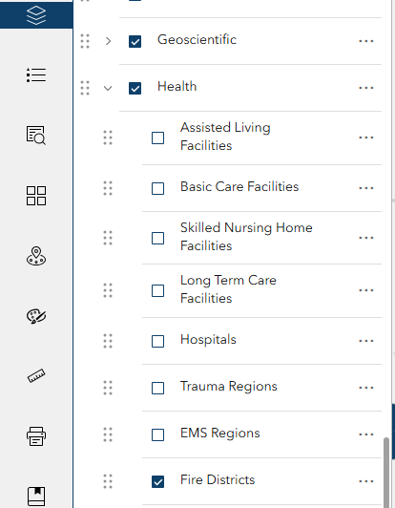

Companies wishing to download the shape file can visit NDGISHUB Fire Districts | North Dakota GIS Hub Data Portal.
Please contact Nichole Feldman nrfeldman@nd.gov for website navigation assistance or Marcy Ost malost@nd.gov if you have any questions pertaining to fire district changes.

